Module 5: Storytelling Techniques

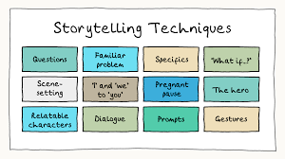
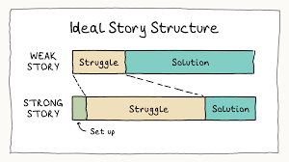
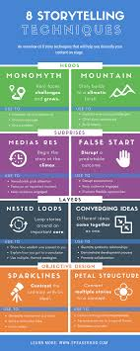
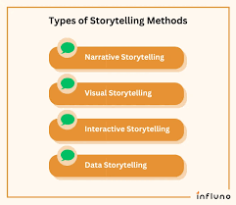

Storytelling is an art that relies on various techniques to captivate an audience. While every storyteller develops their own style, mastering fundamental techniques enhances delivery and engagement.
Projection, Articulation, and Voice Variation
A storyteller’s voice is their most powerful tool. These techniques ensure clarity, audibility, and emotional depth:
- Projection – The ability to project your voice ensures that every word reaches the audience. Proper breath control and diaphragm support help maintain volume without strain.
- Articulation – Clear pronunciation prevents misinterpretation. Practicing tongue twisters and enunciation exercises improves articulation.
- Voice Variation – Changing pitch, tempo, and intonation adds dynamism to storytelling. A well-modulated voice keeps the audience engaged and conveys emotions effectively.
Facial Expressions and Body Movement
Non-verbal communication enhances storytelling by reinforcing emotions and actions:
- Facial Expressions – Expressions strengthen meaning and help the audience connect with the story’s emotions. A storyteller’s face should reflect the mood of the narrative.
- Body Movement – Gestures and movements complement words, making the story more immersive. However, movements should be purposeful and coordinated to avoid distraction.
Balancing Storytelling and Acting
While storytelling involves performance elements, it differs from acting in key ways:
- Characterisation – Storytellers imitate characters rather than fully embodying them. They shift between roles while maintaining their identity as the narrator.
- Audience Engagement – Unlike acting, storytelling often involves direct interaction with the audience through questions, chants, or participation.
- Rhythm and Repetition – A rhythmic voice enhances storytelling aesthetics. Repetition reinforces themes and helps audiences remember key moments.
- Use of Idiophones – Sound effects mimic real-world noises, enriching the story’s atmosphere.
Exercise: Practice articulation, voice projection, and intonation using a short paragraph from a book.
Assignment: Perform a two-minute monologue, focusing on voice variation and body movement.

